Introduction
The goal and mission of the Sustainable Rivers Program (SRP) is to improve the health and life of rivers by modifying operations of U.S. Army Corps of Engineers (USACE) water resources infrastructure to restore and protect ecosystems, while maintaining or enhancing other project benefits. For the Tennessee‑Tombigbee Waterway (TTWW), SRP efforts focus on the Old Tombigbee River and its tributaries downstream of Wilkins Lock and Dam, where altered hydrologic regimes, sedimentation, and operational flow recessions affect critical mussel habitat.
Since FY23, USACE Mobile District and its partners have worked to characterize baseline physical and ecological conditions, understand how TTWW operations influence the Old Tombigbee River, and identify opportunities to improve flow regimes for mussels while preserving navigation, mitigation, and recreation benefits. The 2023 Mussel Habitat Study established sediment and water‑quality baselines, documented mussel assemblages and habitat conditions, and gathered stakeholder input on potential operational improvements. The 2024 SRP Annual Report built on that foundation by mapping gravel bars, quantifying a 27.3‑acre reach‑wide “Stranding Zone,” and measuring hazardous natural dewatering rates and operational lag times, leading to a primary recommendation to actively manage flow recession rather than only monitor it.
This FY25 report documents the next phase of work: developing the hydrologic tools and predictive relationships needed to implement active recession management downstream of Wilkins Lock and Dam. Specifically, the study focuses on (1) building continuous, high‑resolution spillway discharge records, (2) establishing and rating a new gaging station at Blue Water Creek immediately below the Wilkins spillway, (3) refining hydrologic travel times between Wilkins, Blue Water Creek, and the Tombigbee River at the Bigbee gage, and (4) developing a predictive stage model for the Nettleton gravel bar, a critical mussel habitat.
The FY25 Scope of Work identified two closely linked tasks: continued data gathering and analysis, and operational testing of environmental flow releases at Wilkins. Within this framework, the specific objectives of the FY25 effort were to:
Continue sediment and water‑quality monitoring at the Bigbee gage to provide watershed‑scale context for operational changes.

Develop and validate a continuous 15‑minute theoretical spillway discharge series based on the official 45‑step operating schedule and observed gate configurations.
Install, calibrate, and rate the Blue Water Creek gage to generate a local stage–discharge relationship for spillway outflows and downstream habitats.
Refine estimates of hydrologic travel times between Wilkins spillway, Blue Water Creek, and the Bigbee gage under different seasonal flow regimes.
Construct and validate a multiple linear regression model relating spillway discharge and mainstem discharge at Bigbee to water depth at the Nettleton gravel bar, with emphasis on ecologically critical drawdown rates.
Use these tools to evaluate FY25 environmental flow releases, inform ramp‑down strategies that reduce mussel stranding risk, and support development of an implementation framework and draft operating guidance for FY26.

Tennessee‑Tombigbee Waterway and Study Area
The Tombigbee Watershed drains roughly 1,800 square miles of northeastern Mississippi and western Alabama and consists of two interconnected components: the Tennessee‑Tombigbee Waterway (TTWW) and the original Tombigbee River. The TTWW, completed in 1984, provides a navigation corridor between the Tennessee River and the Gulf Coast and has three authorized purposes: navigation, wildlife mitigation, and recreation. The waterway forms a 234‑mile long, 300‑foot wide, 9‑foot deep transportation artery with ten navigation locks that lift vessels a total of 341 feet in elevation.
The historic headwaters of the Tombigbee River, also known as the East Fork, lie adjacent to several TTWW pools, including those impounded by the Whitten, Montgomery, Rankin, Fulton, Wilkins, Amory, and Aberdeen Locks and Dams. Minimum‑flow structures at Montgomery and Wilkins provide continuous base inflows to the Tombigbee River, and off‑channel spillways at these projects can route additional water from the navigation channel to the river when local inflows and minimum flow releases are insufficient to meet mitigation flow requirements. Downstream of Wilkins, the Old Tombigbee River is a moderate‑gradient, gravel‑bed system with numerous alluvial bars that provide critical habitat for freshwater mussels.
For this study, the primary focus area extends along the Old Tombigbee River on the west side of the TTWW canal section, from the USGS Fulton gage (02431000) upstream to the USGS Bigbee gage (02433500) near Highway 6 downstream. Within this corridor, Wilkins Lock and Dam on the canal routes water to the Old Tombigbee via the Blue Water Creek spillway. The USGS Fulton gage, Gravel Bar 9 (also referred to in this report as the Nettleton gravel bar), and the Bigbee gage are all located on the Old Tombigbee River downstream of this connection. This alignment makes the Old Tombigbee the primary axis for evaluating how Wilkins spillway operations and watershed inflows affect mussel habitat and stranding risk.
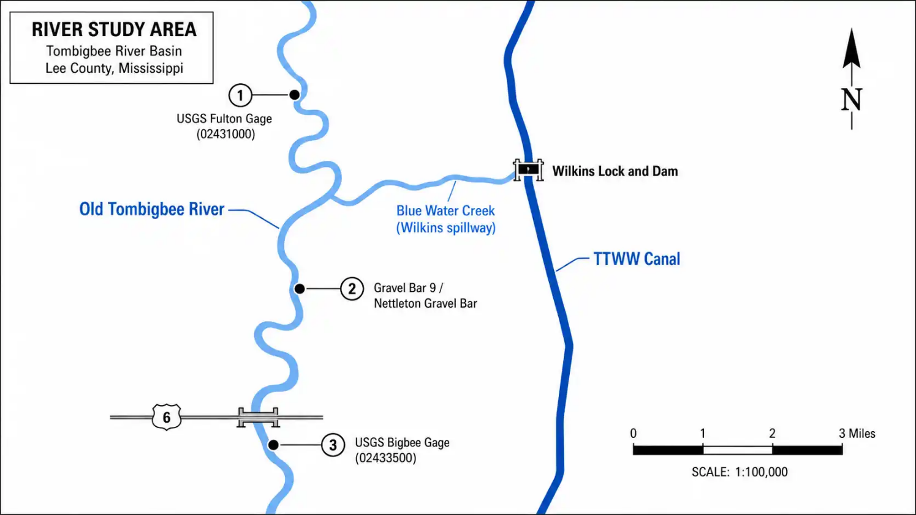

Methods

Overview of Analytical Workflow
The FY25 study methods build directly on the baseline geomorphic, hydraulic, and ecological assessments completed in FY23–FY24. The 2023 Mussel Habitat Study documented sediment and water‑quality conditions, mussel assemblages, and limiting factors across the Old Tombigbee River. The 2024 SRP Annual Report quantified gravel bar geomorphic sensitivity, mapped a 27.3‑acre system‑wide “Stranding Zone,” and measured hazardous natural dewatering rates and operational lag times at Gravel Bar 9.
The FY25 work extended this foundation in two main directions:
Development of continuous, high‑resolution discharge records for Wilkins Spillway and Blue Water Creek, and

Construction of a predictive model relating upstream discharges to water depth at the Nettleton gravel bar.
The analytical workflow consisted of four linked components:
Compilation and standardization of operational and hydrologic data for Wilkins Lock and Dam, Blue Water Creek, and the Old Tombigbee River.
Development and validation of a continuous spillway discharge model based on the USACE 45‑step operating schedule.
Installation and rating of a new continuous gage on Blue Water Creek to provide a local stage–discharge relationship.
Development of a multiple linear regression (MLR) model to predict water depth at Nettleton from spillway discharge and mainstem flow at the Bigbee gage.

Data Sources
Spillway Discharge Methodology
Closest‑Match Algorithm
The official USACE Water Control Manual defines spillway discharge capacity using a discrete, 45‑step operational schedule for the eleven‑gate spillway. Real‑world operations, however, frequently employ intermediate and nonuniform gate configurations that do not correspond exactly to any single schedule step. To represent these continuous operations in a way that remains consistent with the official rating schedule, a “Closest‑Match” algorithm was implemented.
At each timestamp, the observed gate configuration is represented as an 11‑element vector of individual gate openings (ft). For each observed configuration, the algorithm:
- Treats the observed gate settings as an 11‑dimensional vector.
- Computes the Euclidean distance between the observed vector and each of the 45 standard vectors defined by the schedule steps.
- Identifies the schedule step with the minimum Euclidean distance as the representative operational state.
- Looks up the corresponding theoretical discharge from the rating schedule for that step, interpolated based on the concurrent tailwater elevation.
The resulting theoretical spillway discharge for each 15‑minute interval is referred to as
𝑄 Spillway or 𝑄Spill_Calculated

ADCP Field Validation and QA/QC
To verify that the algorithm faithfully reproduces physical discharge, model outputs were validated against independent ADCP measurements collected downstream of the spillway. Five discrete ADCP discharge measurements were obtained between February 2025 and February 2026. For each measurement:
- The exact timestamp was matched to the MOB36 logs to retrieve the gate configuration and pool/tailwater elevations.
- The Closest‑Match algorithm was applied to compute the theoretical schedule‑based discharge.
- Percent error was calculated as the difference between the ADCP measurement and the modeled discharge.
During validation, a large outlier was initially observed for the peak flow event on 13 February 2025. Review of ADCP field notes against the MOB36 log identified a control room data‑entry error: the log recorded all gates at 1.0 ft (Schedule Step 23), while the field notes documented all gates at 0.5 ft (Schedule Step 12). After correcting the boundary conditions to Step 12, the modeled discharge aligned closely with the measured ADCP value, and the error dropped to an acceptable level.
Overall validation indicated:
- Conservative performance and greater sensitivity to local physical factors at very low flows.
- Slight underestimation at moderate flows.
- Good agreement for major spillway events once log errors were corrected.
These results support the use of the Closest‑Match algorithm as a reliable method for generating continuous theoretical spillway discharge.

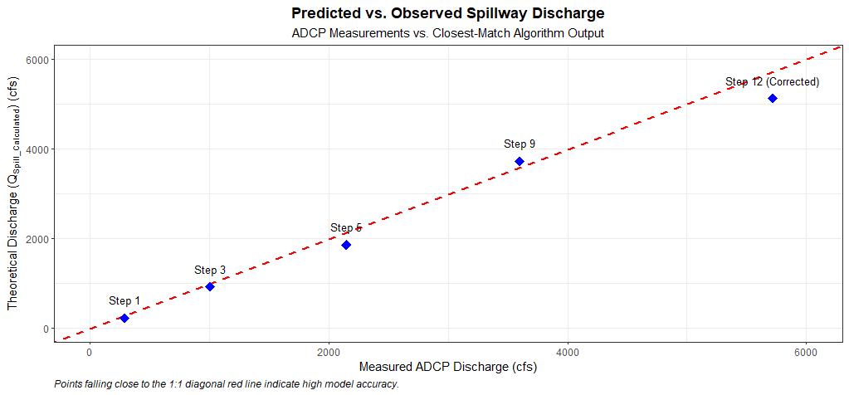
Figure 1: Predicted vs. Observed Spillway Discharge

Continuous Spillway Discharge Modeling (2024–2026)

Data Ingestion and Transformation
The raw operational data was sourced from the official USACE MOB36 monthly logs spanning January 1, 2024, through the present. These logs record the exact timestamp of every manual gate adjustment, including the upper pool elevation, tailwater elevation, and the specific opening (in feet) for each of the 11 spillway gates. In total, 1,282 distinct operational changes were recorded during this period.
Due to the discrete nature of manual gate operations, the raw data inherently consists of irregular time intervals. To create a standardized foundation for the hydrologic routing models, these irregular records were transformed into a uniform time series using R.

A standard interval of 15 minutes was selected to balance computational efficiency with the required fidelity to capture rapid operational changes. The transformation utilized a "Last-Observation-Carried-Forward" (LOCF) methodology. For any 15-minute interval lacking a new operational entry, the algorithm carried forward the exact gate configuration and pool elevations from the most recent preceding log entry. This accurately simulates the physical reality of the structure: a gate setting remains constant and continues discharging water until an operator explicitly records a change.

Continuous Discharge Calculation (Q_{Spill_Calculated})

Time‑Series Standardization
Because manual spillway operations occur at irregular intervals, the raw MOB36 data are irregular in time. To support time‑series analysis and hydrologic modeling, the operations record was resampled to a uniform 15‑minute interval. The following procedure was applied:
- The original MOB36 records were sorted chronologically.
- A regular 15‑minute timestamp series was generated for the analysis period.
- A Last‑Observation‑Carried‑Forward (LOCF) approach was used to populate each 15‑minute step with the most recent preceding gate configuration and pool/tailwater elevations.

Application of the Closest‑Match Algorithm
Once the 15‑minute boundary conditions were established, the Closest‑Match algorithm was applied to every time step in the 2024–2026 period:
- Construct the 11‑gate operational vector for each 15‑minute timestamp.
- Compute Euclidean distances between the observed vector and all 45 schedule steps.
- Identify the step with minimum distance as the representative state.
- Use the schedule and concurrent tailwater elevation to compute theoretical discharge for that step.
The result is a continuous 15‑minute theoretical spillway discharge record, 𝑄_Spillway
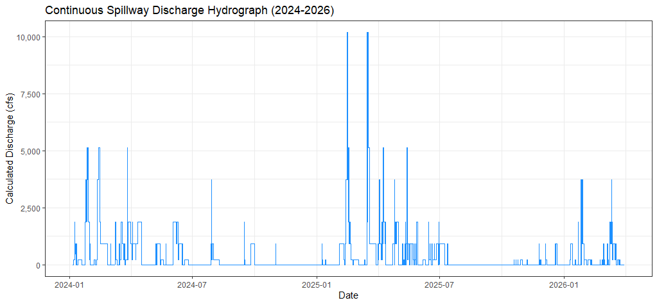
Figure 2: Continuous 3-Year Spillway Hydrograph

Annual Statistical Aggregation
To summarize long‑term operation patterns and provide inputs to ecological analyses, the 15‑minute discharge series was aggregated annually. For each calendar year:
- Minimum discharge.
- Mean discharge.
- Maximum discharge.
were computed, with 2026 statistics limited to the period 1 January–31 March. These metrics were used later to characterize operational intensity across years and to identify key spillway events.
Table 2: Annual Theoretical Spillway Discharge Statistics
Year | Minimum Discharge (cfs) | Mean Discharge (cfs) | Maximum Discharge (cfs)
2024 | 0 | 341.93 | 5,128
2025 | 0 | 396.60 | 10,181
2026* | 0 | 290.17 | 3,729

Operational Patterns and Observations
The statistical analysis of the modeled time series highlights several defining characteristics of the spillway's operation:
Episodic Flow Regimes: The minimum discharge for all years is 0 cfs. This confirms that the spillway gates are frequently fully closed, indicating that the structure operates episodically to pass distinct flood pulses rather than maintaining a continuous baseflow. (Baseflow in the downstream Tombigbee River is primarily maintained via lockages and the adjacent hydropower/bypass structure, which are modeled separately).
Peak Event in 2025: The year 2025 contained the most aggressive operational period, featuring the highest recorded peak discharge of 10,181 cfs (corresponding to Schedule Step 23, with all 11 gates open to 1.0 ft).

Higher Sustained Operations: 2025 also exhibited the highest annual mean discharge (396.60 cfs). While the mean appears low relative to the peak, this average includes the numerous periods of zero flow, indicating that when the gates were open in 2025, they were open wider or for longer durations than in 2024.
Spring 2026 Observations: The partial data for Q1 2026 captured a moderate spring flow event peaking at 3,729 cfs (Schedule Step 9).

Blue Water Creek Gage and Rating Curve
Station Configuration and Rebuild
The Blue Water Creek gage was established on 6 January 2025 to provide a local measure of stage and discharge immediately downstream of Wilkins Spillway. The station is located on the right descending bank approximately 0.75 miles below the spillway. It consists of:
A Waterlog H‑522+ DCP for data logging and telemetry.
A Waterlog H‑310 pressure transducer mounted inside protective stilling infrastructure.
Hourly GOES telemetry to transmit 15‑minute stage data.
During the initial operational period (January–May 2025), the transducer became dislodged from the channel bed on 16 May 2025, resulting in invalid stage readings. Between 3–4 June 2025, USACE staff rebuilt and hardened the station, including installation of a new platform tower, staff plates, and improved bank stabilization. New levels were run on 4 June 2025, establishing benchmark and reference mark elevations and linking staff readings to a local stage datum.

ADCP Discharge Measurements
To develop a stage–discharge rating curve, five independent ADCP measurements were collected between January 2025 and June 2026 under a range of flow conditions. For each measurement:
- Instantaneous stage was recorded at the gage.
- Cross‑sectional mean velocity and area were measured with the ADCP.
- Discharge was calculated by integrating velocity over the cross section.

These paired stage–discharge data were used to calibrate a regression‑based rating curve.

Rating Curve Development
A power‑law function was selected for the stage–discharge relationship:

𝑄 = 𝑎 ⋅(𝑆𝑡𝑎𝑔𝑒−𝑆0)𝑏
Q=a⋅(Stage−S 0) b

where
𝑄=Q is discharge (cfs),
Stage is corrected water‑surface elevation (ft),
𝑆0 is the effective stage of zero flow, and
a and 𝑏 b are fitted coefficients.
Using nonlinear regression on the five ADCP events, the following equation was obtained:
𝑄=112.8⋅(𝑆𝑡𝑎𝑔𝑒−4.46) 1.77
with a coefficient of determination
𝑅2=0.939indicating a strong fit to the empirical data. This equation was then applied to the continuous 15‑minute stage series from Blue Water Creek to generate a local discharge time series for use in system validation and ecological modeling.
System Validation: Spillway Model vs Local Rating Curve
To determine the most appropriate continuous discharge representation for downstream ecological analysis, the theoretical spillway discharge model and the Blue Water Creek rating curve were evaluated against the same set of ADCP measurements.
For each of the five ADCP measurement times:
The spillway model was run using the concurrent MOB36 gate configuration and tailwater, and the Closest‑Match algorithm produced a theoretical schedule‑based discharge.
The Blue Water Creek rating curve was evaluated using the recorded stage at the Blue Water Creek gage.

Both modeled discharges were compared to the ADCP‑measured discharge, and percent errors were computed.
- This comparison allowed direct assessment of:
- The ability of upstream gate‑based modeling to reproduce local conditions.
- The accuracy and robustness of the local rating curve across flow ranges.
The resulting error patterns guided the selection of the Blue Water Creek rating curve as the canonical continuous discharge model for local ecological analysis, while identifying the spillway model’s role as an operational indicator rather than a fine‑scale local predictor.

Event Isolation and Lag Time Calculation
A critical component of downstream ecological management is understanding how quickly a change in spillway operations at the Glover Wilkins Lock & Dam will manifest as a change in stage and velocity at downstream habitats. To quantify this hydrologic lag time, the 2024–2026 continuous theoretical discharge time series was paired with continuous flow and stage data from the downstream USGS streamgage located on the Tombigbee River at Bigbee, MS.
To calculate accurate travel times, "clean" hydrologic events were isolated from the multi-year dataset. A clean event was defined by the following criteria:
A distinct, rapid increase in spillway gate openings (e.g., transitioning from 0 cfs to >2,000 cfs within a short window).
The event occurred during a period of otherwise stable, low-to-moderate baseline flow in the Tombigbee River.
No significant localized rainfall events occurred between the dam and the Bigbee gage that would artificially alter the downstream hydrograph.
For each isolated event, the start time was established as the timestamp of the initial gate opening at the spillway. The end time was defined as the timestamp of the corresponding peak stage reading at the USGS Bigbee gage. The lag time was calculated as the delta between these two points.

Winter Low-Flow Event (January 30 - February 2, 2025)

A large spillway release occurred during a period of otherwise low and stable river flow.

Method: A cross-correlation was performed exclusively on this clean event window.

Result: The analysis produced a clear and robust result with a single, strong peak correlation.

Calculated Lag Time: 14.25 hours.
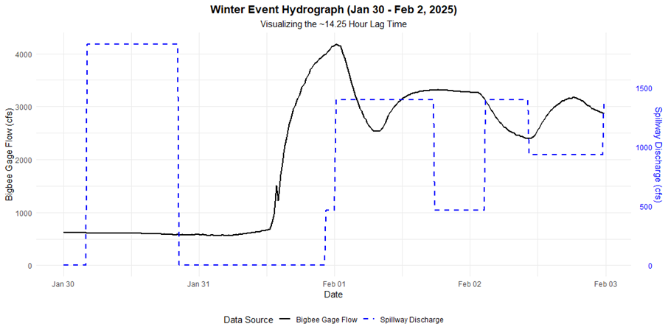

Summer Low-Flow Event (July 17, 2025)

A smaller spillway release occurred during a period of very low summer baseflow, with no significant upstream inflows from the Fulton gage.
Method: Due to the lower signal-to-noise ratio in this event, a direct visual analysis of the plotted hydrographs was determined to be the most reliable method. The time difference between the start of the spillway release and the start of the corresponding rise at the Bigbee gage was measured.
Calculated Lag Time: Approximately 4.0 hours.
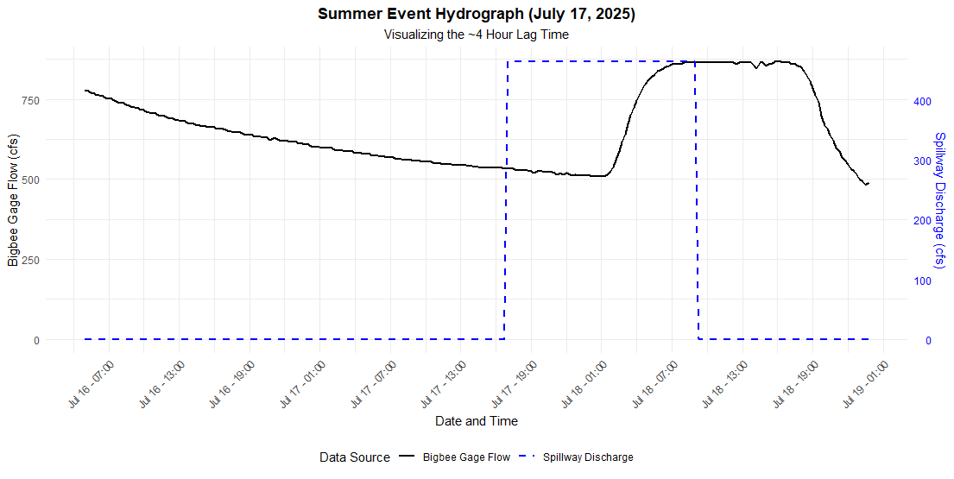
Conclusion on System Lag Structure
The event-based analysis successfully quantified the travel time and revealed a critical, seasonal dependency.
Condition | Travel Time (Spillway to Bigbee)
Winter, Low-Flow | ~14.25 hours
Summer/Spring, Low-Flow | ~4.0 hours

Predictive Stage Model for Nettleton Gravel Bar

Ecological Significance of Nettleton Gravel Bar
The Nettleton gravel bar, located downstream of the Glover Wilkins Lock and Dam, is a critical habitat for several species of freshwater mussels. These organisms are highly sensitive to rapid changes in water level. A sudden decrease in stage, or "drawdown," can expose the mussels, leading to desiccation, thermal stress, and mass mortality (stranding). Your previous analysis identified a critical drawdown threshold of -0.25 ft/day (-0.0104 ft/hr) beyond which these hazardous stranding events occur.
To mitigate this risk, it is necessary to predict how changes in upstream dam operations will translate to changes in water depth at this specific location.

Model Development
A Multiple Linear Regression (MLR) model was developed to predict the water depth at Nettleton. The model uses two readily available upstream variables as predictors:
Q_Spillway: The calculated theoretical discharge from the Glover Wilkins Spillway (cfs), derived from the 15-minute continuous time series.
Q_Bigbee: The observed discharge from the USGS gage on the Tombigbee River at Bigbee, MS (cfs).
The dependent variable is the water depth at Nettleton (ft), which was derived from on-site HOBO logger pressure transducer data, corrected to a baseline elevation of 205.175 ft.

Final Predictive Equation and Performance
The resulting regression model produced the following predictive equation:
Predicted Nettleton Depth (ft) = -0.1271 + (0.0023 * Q_Spillway) + (0.0012 * Q_Bigbee)
This model proved to be highly effective, achieving an Adjusted R-squared value of 0.8873.
This high R-squared value indicates that 88.73% of the observed variation in water depth at the Nettleton gravel bar can be statistically explained by the combined discharge from the Wilkins Spillway and the Bigbee gage.

Implementation and Use
This equation is a core component of the operational ramp-down strategy. By inputting the planned changes in spillway discharge and the current flow at the Bigbee gage, the model allows control room operators to forecast the resulting change in water depth at Nettleton before making the operational change.

Mussel Monitoring

Survey design and objectives
Mussel monitoring in FY25 was designed to (1) document the composition and relative abundance of mussel assemblages at representative gravel bars upstream and downstream of the Wilkins spillway and (2) provide habitat‑specific context for evaluating potential effects of flow recession and spillway operations on mussel populations. Three sites were surveyed:

- Lost Corner – located upstream of Blue Water Creek on the Old Tombigbee River, representing conditions less directly influenced by Wilkins spillway operations.
- Nettleton – a high‑priority gravel bar downstream of Blue Water Creek.
- Standifer Creek Hunting Club – a downstream reach characterized by extensive gravel habitat and known mussel resources.
At each site, three transects were established across accessible portions of the bar, and timed searches were conducted to supplement quadrat sampling and increase detection of less abundant or patchily distributed species.

Transect layout and quadrat sampling
Transects were laid out approximately perpendicular to flow across the wetted gravel bar surface at the time of the survey. Each transect was subdivided into five 0.25 m² quadrats (Q1–Q5) spaced evenly along its length (typically 18–42 m, depending on site width). Within each quadrat, the following data were collected:
Dominant substrate type (for example, sand over small gravel, sandy gravel, gravel with coarse sand, silt over sand).
Water depth (ft) measured at the quadrat center.
Near‑bed velocity components (Vx, Vy) from a hand‑held current meter and velocity magnitude
V (ft/s).
Presence and identity of live and dead mussels, including Corbicula (Asian Basket Clam).
For each live unionid encountered, species and shell measurements (length, width, height in mm) were recorded. Recently dead shells were noted separately where encountered.

Timed searches
Following completion of quadrat sampling on each transect (or group of transects), timed searches were conducted in nearby habitats judged to be similar or slightly higher quality than the transect locations. Timed searches were semi‑quantitative visual/tactile surveys in which snorkelers or waders systematically searched the bed surface and shallow subsurface for a fixed period (typically 15–30 minutes) within a defined area around the transect.
All live unionids encountered during timed searches were identified to species and measured (length, width, height). Corbicula were enumerated where feasible, with notes made when abundances were too high to count reliably. Timed searches were used to augment quadrat data, detect additional species not intersected by the fixed plots, and better characterize mussel distribution across each bar.

Site positioning relative to Wilkins spillway
Lost Corner is located on the Old Tombigbee River upstream of the Blue Water Creek confluence and thus receives natural watershed flows but is less directly affected by Wilkins spillway operations. Nettleton and Standifer Creek Hunting Club lie downstream of Blue Water Creek, within the reach where Wilkins spillway releases and subsequent flow recessions are expected to have the greatest influence on stage and potential mussel stranding. This upstream–downstream arrangement allows the Lost Corner assemblage to serve as a qualitative reference for conditions above the spillway influence.

Results

Continuous Spillway Discharge (2024–2026)
The Closest‑Match algorithm produced a complete 15‑minute theoretical discharge record for Wilkins Spillway from 1 January 2024 through 31 March 2026. The three‑year hydrograph shows episodic operation, with extended periods of zero discharge punctuated by discrete spillway releases of varying magnitude and duration (Figure 2).

Annual statistics for the modeled spillway discharge are summarized in Table 2. Minimum discharge was 0 cfs in all years, reflecting frequent periods when all spillway gates were fully closed. Mean annual discharge ranged from 290.17 cfs (partial year, 2026) to 396.60 cfs (2025), while maximum discharge ranged from 3,729 cfs (2026) to 10,181 cfs (2025). The highest recorded event, 10,181 cfs, occurred in 2025 and corresponds to Schedule Step 23, with all 11 gates open to 1.0 ft.
These statistics indicate that 2025 contained both the largest single spillway event and the highest overall level of spillway usage, with gates open wider and/or for longer durations than in 2024, despite numerous intervals of zero flow.

Spillway Model Validation Against ADCP Measurements
Five discrete ADCP measurements collected downstream of the spillway between February 2025 and February 2026 were used to evaluate the performance of the Closest‑Match algorithm. After correction of the February 13, 2025 boundary conditions to match the field‑observed gate settings, modeled discharges agreed well with ADCP measurements across a range of flows.
For the four lower‑flow events, percent error between the modeled schedule discharge and the ADCP discharge ranged from approximately −20% at very low flow to +3.6% at upper moderate flow. The corrected high‑flow event on 13 February 2025 exhibited an error of −10.35%. In general, the spillway model tended to slightly underestimate discharge at low to moderate flows and matched large spillway events to within about 10–11% once control room logging errors were addressed.
These results confirm that the Euclidean Closest‑Match approach is able to reproduce the official 45‑step schedule behavior and provides a sufficiently accurate continuous spillway discharge record for subsequent hydrologic and ecological analyses.

Blue Water Creek Rating Curve and Local Discharge
The Blue Water Creek gage recorded continuous stage data suitable for rating‑curve development after the June 2025 rebuild. Five ADCP discharge measurements collected between January 2025 and June 2026, spanning low to moderate flows, were used to calibrate a power‑law stage–discharge relationship.
The final rating curve, Q=112.8⋅(Stage−4.46)^{1.77} achieved a coefficient of determination of 𝑅²=0.939 against the ADCP measurements. When applied to the 15‑minute stage record, this equation produced a continuous local discharge time series for Blue Water Creek and the Old Tombigbee immediately below the Wilkins spillway.

Comparison of modeled discharges to the ADCP measurements indicated that the Blue Water Creek rating curve reproduced local flows with relatively low error across the calibrated range. For the two largest events (February 12 and 13, 2025), rating‑curve errors were −4.37% and +9.63%, respectively, whereas the spillway model errors for the same events were −19.19% and +66.73%. One event (April 8, 2025) exhibited a larger rating‑curve error of +57.11%, consistent with transient backwater or sensor effects at the time of measurement, and a February 17, 2026 event produced a −100% error due to stage falling below the defined zero‑flow stage, resulting in a computed discharge of 0 cfs despite a measured 290 cfs.
Overall, these comparisons indicate that the Blue Water Creek rating curve provides the most accurate representation of local discharge at the gage for the flow ranges of greatest ecological interest, while the spillway model remains useful for characterizing upstream operations and timing.

Hydrologic Lag Between Wilkins and Bigbee
Two clean spillway events were used to refine travel‑time estimates between Wilkins Lock and Dam and the USGS Bigbee gage under contrasting seasonal conditions. A winter low‑flow event between 30 January and 2 February 2025 was analyzed using cross‑correlation of spillway discharge and Bigbee stage. The cross‑correlation function exhibited a single strong peak at a lag of 14.25 hours, indicating a well‑defined winter travel time from Wilkins to Bigbee.
A summer low‑flow event on 17 July 2025 was analyzed by direct visual comparison of the spillway and Bigbee hydrographs. During this event, the time difference between the onset of the spillway release and the onset of the corresponding stage rise at Bigbee was approximately 4.0 hours.
Together, these results indicate a pronounced seasonal dependence in travel time between Wilkins and Bigbee, with winter low‑flow travel times on the order of 14.25 hours and summer/spring low‑flow travel times on the order of 4 hours. These travel‑time estimates define the operational windows within which changes at Wilkins can influence downstream stage at Bigbee.

Predictive Stage Model for Nettleton Gravel Bar
The multiple linear regression model relating spillway discharge and mainstem flow to water depth at the Nettleton gravel bar performed well over the calibration dataset. The final model, DepthNettleton​=−0.1271+0.0023⋅QSpillway​+0.0012⋅QBigbee​ achieved an adjusted ^{𝑅2} of 0.8873, indicating that approximately 88.7% of the observed variance in Nettleton water depth is explained by the combination of theoretical spillway discharge and observed discharge at Bigbee. Predicted depths closely tracked observed HOBO‑derived depths across a wide range of flow conditions, with residuals centered near zero and no consistent bias across low, moderate, and high flows. When converted to drawdown rates, the modeled time series captured both gradual recessions and steeper natural drawdowns at Nettleton, providing a basis for evaluating whether proposed operational changes at Wilkins would cause water‑level declines to exceed the −0.25 ft/day ecological threshold.
These results demonstrate that a simple two‑predictor model using only Wilkins spillway discharge and Bigbee discharge is capable of predicting Nettleton water depth with sufficient accuracy for operational screening and ramp‑down planning.

Mussel Monitoring

Lost Corner
Three transects and associated timed searches were completed at Lost Corner. Depths ranged from roughly 0.9–4.3 ft, and substrates included sandy over small gravel, large gravel over sand, sand over small gravel, fine sand over gravel and wood, wood over silt, silt over gravel, fine sand and silt, sand over pea gravel, coarse sand over gravel, sandy gravel, and large gravel with coarse sand.
Quadrat sampling along Transect 1 documented Lampsilis ornata (Southern/Ornate Pocketbook), Rotundaria asperata (Alabama Orb), Potamilus fragilis (Fragile Papershell), and Corbicula in shallow sand‑over‑gravel habitats. The timed search in this reach recorded additional Lampsilis ornata, Amblema plicata (Three Ridge), and Lampsilis teres (Yellow Sandshell), including several recent dead shells, indicating both active occupancy and recent mortality.
Transect 2 quadrats yielded Ellipsaria lineolata (Butterfly) and Corbicula, with additional unionids (Southern Pocketbook, Alabama Orb, Three Ridge, Bleufer, Gulf Mapleleaf, and Butterfly) detected in the timed search. Transect 3, despite coarse gravel and moderate velocities, produced no unionids in quadrats or timed searches. Overall, Lost Corner supported a diverse assemblage of common unionids concentrated in mixed sand–gravel habitats, with patchy occupancy in coarser sections and widespread Corbicula.

Nettleton
At Nettleton, three transects and timed searches characterized mussel use of the bar. Transect 1 crossed sand over pea gravel, sand over gravel, sandy gravel, pea gravel with sand, and fine sand over gravel at depths of ~1.3–2.3 ft. A single Southern Pocketbook was recorded in the first quadrat; quadrats Q2–Q5 were mussel‑free, and no additional mussels were observed in the associated timed search.
Transect 2 consisted primarily of fine sand and silt over sand, with gravel several inches below the surface in places and numerous soft, mushy patches at depths up to ~3.1 ft. No mussels were found in quadrats or timed searches in this finer, low‑velocity portion of the bar.
Transect 3 traversed gravel and large gravel with coarse sand at depths of ~0.4–2.5 ft. Quadrats did not yield unionids, but the timed search documented multiple large unionids, including Potamilus inflatus (Inflated Heelsplitter), Alabama Orb, and additional Southern Pocketbooks, along with numerous Corbicula. These observations show that while quadrat‑scale density was low, discrete coarse gravel patches within the Nettleton bar support several long‑lived, high‑value mussel species.

Standifer Creek Hunting Club
The Standifer Creek Hunting Club site supported the densest and most diverse mussel assemblage among the three locations. Transect 1 crossed shallow (0.3–1.0 ft) “gravel, coarse sand, and filamentous algae” through “primarily sand with pea gravel.” Corbicula were abundant in all quadrats (up to 6 individuals per quadrat). Timed Search 1 documented multiple Southern Pocketbooks and Alabama Orbs, as well as male and female Quadrula nobilis (Gulf Mapleleaf), indicating robust, reproducing populations in these shallow, coarse habitats.
Transect 2 spanned “sand and mixed‑size gravel,” “sand over gravel,” and “mainly gravel” at depths of ~0.9–3.0 ft with moderate velocities. Corbicula and a Southern Pocketbook were recorded in quadrats. Timed Search 2 yielded Truncilla truncata (Deer Toe), Inflated Heelsplitter, and additional Southern Pocketbooks, confirming high‑quality unionid habitat in this reach.
Transect 3 and its nearby timed searches extended into deeper (up to ~4.3 ft) silt‑over‑gravel and sand‑over‑gravel substrates. Quadrats in Transect 3 contained no unionids, but Timed Search 4 documented numerous large Inflated Heelsplitter, Southern Pocketbook, and Alabama Orb individuals. Together, these observations demonstrate that the Standifer Creek site supports a high‑density, multi‑species unionid community across a range of depths and substrates, with particularly important patches in shallow and moderate‑depth coarse gravel.
2.4 Comparative site summary
Across all three sites:
Species richness and composition. All sites supported multiple unionid species, with Standifer Creek showing the greatest apparent richness and density, Lost Corner intermediate, and Nettleton the sparsest quadrat‑scale densities but still containing large, high‑value individuals in coarse patches. Common species across sites included Southern Pocketbook, Alabama Orb, and Corbicula; Inflated Heelsplitter and Gulf Mapleleaf were confirmed at downstream sites.
Habitat associations. Mussels were most frequently associated with mixed sand–gravel and coarse gravel substrates at shallow to moderate depths (approximately 0.5–3 ft) and low to moderate velocities. Fine sand/silt and soft, mushy substrates (for example, Nettleton Transect 2) were consistently devoid of unionids.

Upstream vs downstream pattern. The upstream Lost Corner site supports a diverse assemblage in mixed sand–gravel habitats, while downstream sites—particularly Standifer Creek—support higher densities and larger individuals in coarse gravel patches, despite the influence of managed flows from Wilkins spillway.
Yes—adding that table will help your readers see the big picture very quickly. Here’s a comparison table based on the data you shared for the three sites, followed by a short paragraph you can paste at the end of the Mussel Results or in the Discussion.
You can refine species counts if you later tally them precisely, but this captures the main patterns.

- Comparative mussel assemblage summary
Table X. Summary of mussel assemblages and habitat quality at three survey sites
Site | Position vs Blue Water Creek | Approx. unionid species detected* | Notable / sensitive species observed** | Qualitative habitat rating (for mussels)
Lost Corner | Upstream | ~8–9 | Ellipsaria lineolata (Butterfly), Quadrula nobilis (Gulf Mapleleaf), Lampsilis teres (Yellow Sandshell), Potamilus fragilis (Fragile Papershell) | Moderate–High: diverse assemblage concentrated in mixed sand–gravel habitats; patchy occupancy in coarser areas; Corbicula common
Nettleton gravel bar | Downstream | ~3–4 | Potamilus inflatus (Inflated Heelsplitter), Rotundaria asperata (Alabama Orb), Lampsilis ornata (Southern Pocketbook) | Moderate: low quadrat densities but several large, high-value individuals in coarse gravel patches; extensive fine-sand/silt zones with no mussels
Standifer Creek Hunting Club | Downstream | ≥7–8 | Potamilus inflatus (Inflated Heelsplitter), Quadrula nobilis (Gulf Mapleleaf; male and female), Truncilla truncata (Deer Toe), Rotundaria asperata, Lampsilis ornata | High: dense and diverse mussel community in shallow and moderate-depth coarse gravel; Corbicula abundant but unionids remain well-established

The comparative summary indicates that all three survey sites support multi‑species unionid assemblages, but with marked differences in density and habitat use. Lost Corner, located upstream of Blue Water Creek, supports a moderately diverse assemblage typical of mixed sand–gravel habitats, whereas the downstream Standifer Creek site supports the highest observed densities and the greatest number of high‑value species in shallow coarse gravel. Nettleton, although less densely populated in quadrats, contains multiple large Inflated Heelsplitter, Southern Pocketbook, and Alabama Orb individuals in discrete coarse patches, underscoring its importance as a sensitive habitat where rapid stage recession could strand relatively small but ecologically significant mussel populations.

Upstream reference conditions at Lost Corner
Lost Corner, located upstream of Blue Water Creek, provides a useful qualitative reference for mussel assemblages and habitat conditions less directly influenced by Wilkins spillway operations. The presence of multiple common unionid species (Southern Pocketbook, Alabama Orb, Three Ridge, Butterfly, Bleufer, Gulf Mapleleaf, Yellow Sandshell) in shallow mixed sand–gravel habitats indicates that these substrate types naturally support diverse assemblages in the Old Tombigbee. Patchy occupancy of coarser, higher-velocity sections and widespread occurrence of Corbicula suggest that baseline habitat heterogeneity and competition with non-native clams are important controlling factors even in the absence of direct spillway recession effects.

Downstream habitat quality and vulnerability
Nettleton and Standifer Creek, both downstream of Blue Water Creek, support assemblages that are at least as diverse as the upstream reference and, in the case of Standifer Creek, substantially more abundant. The repeated occurrence of large Inflated Heelsplitter, Southern Pocketbook, Alabama Orb, Deer Toe, and Gulf Mapleleaf at these sites demonstrates that the downstream reach continues to function as high‑value mussel habitat under current conditions.
However, the distribution of mussels across the bars is highly patchy. At Nettleton, mussels were concentrated in discrete coarse gravel patches (for example, near Transect 3), while adjacent fine‑sand/silt sections contained no individuals. This patchiness, combined with the shallow depths at which unionids occur (often < 3 ft), makes these populations vulnerable to rapid water‑level recession. Mussels occupying coarse gravel patches near the bar crest are particularly likely to strand if stage declines faster than their ability to move laterally or vertically in the substrate.

Implications of Wilkins operations and Blue Water Creek
Because Lost Corner lies upstream of Blue Water Creek, its assemblage is influenced primarily by watershed hydrology and not directly by Wilkins spillway gate operations. In contrast, both Nettleton and Standifer Creek experience the combined effects of local inflows, minimum flow structures, and managed releases from the Wilkins spillway. The hydrologic analyses in this report show that spillway releases can produce relatively sharp hydrograph peaks and recessions, and that travel times from Wilkins to downstream habitats vary seasonally (on the order of 4 hours in summer low‑flow and 14.25 hours in winter low‑flow).
When rapid spillway recessions occur during low‑flow periods, stage can fall quickly at downstream bars such as Nettleton and Standifer Creek. Given the shallow occurrence of mussels and the concentration of high‑value species in coarse gravel patches, these sites are at elevated risk for stranding if drawdown rates exceed the −0.25 ft/day threshold identified in prior analyses. Observations of recent‑dead shells at Lost Corner, and the presence of large adult mussels in narrow depth bands at Nettleton and Standifer Creek, support the inference that rapid drawdowns can convert suitable habitat into exposed bar surface over short timeframes.

Role of mussel monitoring in ramp‑down design
The mussel monitoring results provide critical biological context for the hydrologic tools developed in this report. The continuous spillway discharge model, Blue Water Creek rating curve, and Nettleton stage regression quantify how Wilkins operations propagate through the system and affect stage at specific bars. The mussel surveys identify which substrates and depth ranges contain high‑value assemblages and therefore require protection from rapid recession.
Together, these datasets support the development of ramp‑down guidance that:
Prioritizes maintaining drawdown rates at or below −0.25 ft/day at Nettleton and other high‑value bars.
Recognizes that coarse gravel patches at shallow to moderate depths (0.5–3 ft) are the most critical zones to keep wetted during managed recessions.
Uses the seasonal travel times and stage models to schedule gate closures at Wilkins so that downstream recession slopes at key habitats remain within ecologically acceptable limits.
Continued mussel monitoring at Lost Corner, Nettleton, and Standifer Creek will allow Mobile District to evaluate how future operational changes affect mussel assemblages over time and to refine ramp‑down criteria as additional data become available.

Discussion

Progress on the FY25 Scope of Work
The FY25 effort substantially advanced the “Path Forward” identified in the 2023 mussel habitat study by moving from descriptive assessments toward quantitative tools that can support day‑to‑day operational decisions at Wilkins Lock and Dam. Work this year successfully:
- Generated a continuous, schedule‑consistent spillway discharge record for 2024–2026.
- Developed and validated a local stage–discharge rating curve at Blue Water Creek.
- Refined travel‑time estimates between Wilkins and downstream gages under contrasting seasonal conditions.
- Built and tested a predictive stage model for the Nettleton gravel bar that links operations to on‑site water depth and drawdown rate.
- Collected targeted mussel and habitat data at one upstream and two downstream bars to ground the hydrologic tools in current biological conditions.
Together, these components meet the FY25 SOW objectives for continued data gathering and analysis and provide the technical foundation needed for operational testing and ramp‑down guidance in FY26.

Understanding Wilkins operations in a habitat context
The continuous spillway discharge model shows that Wilkins spillway operates in an episodic fashion—long periods of zero discharge interrupted by short, often intense releases. Annual statistics highlight that 2025 was the most operationally active year in the three‑year record, with the largest peak spillway discharge (~10,181 cfs) and the highest annual mean discharge, even when zero‑flow periods are included. These patterns align with the project’s role in passing flood pulses while relying on other structures (lockages, minimum‑flow outlets) for baseflow.
From a habitat perspective, the episodic nature of spillway releases is less important than the shape of the recession limb and the timing of releases relative to downstream mussel habitats. The lag analysis demonstrates that spillway changes are expressed at downstream sites over hours, not days—on the order of 14.25 hours in winter low‑flow and about 4 hours in summer low‑flow between Wilkins and the Bigbee gage. This means that rapid gate closures can quickly translate into steep stage declines at bars like Nettleton and Standifer Creek, especially when local inflows are low. The three‑year continuous record now allows these operational patterns to be evaluated directly against habitat‑scale water‑level changes, rather than inferred from sparse gage data or individual events.

Choosing the right discharge signal: spillway model vs local rating curve
Validation against ADCP measurements shows that the Closest‑Match spillway model reproduces the official 45‑step capacity schedule with acceptable error, particularly for larger events once control‑room logging errors are corrected. However, comparison with the Blue Water Creek rating curve reveals that a local, empirically derived stage–discharge relationship provides a more accurate representation of flows at the downstream habitat scale across most of the calibrated range.
Practically, this suggests a division of roles:
- The spillway model is best used to characterize Wilkins operations and as an input variable in predictive tools (for example, the Nettleton regression model), because it reflects how operators actually configure gates relative to the schedule
- The Blue Water Creek rating curve is better suited for evaluating the actual discharge experienced by downstream habitats, especially during low to moderate flows when small errors in discharge can translate to meaningful differences in local stage.
Using both together strengthens the decision framework: operators can see both what they intend to release (schedule space) and what is likely to occur in the river (local discharge and stage).

Mussel assemblages as indicators of critical habitat
Mussel monitoring at Lost Corner, Nettleton, and Standifer Creek demonstrates that the Old Tombigbee River still supports diverse, ecologically important unionid assemblages upstream and downstream of Blue Water Creek. Lost Corner, upstream of the spillway influence, functions as a reference site with moderate species richness in mixed sand–gravel habitats. Nettleton and Standifer Creek, downstream of Blue Water Creek, support comparable or higher richness and contain multiple large individuals of high‑value species such as Inflated Heelsplitter, Gulf Mapleleaf, Deer Toe, Southern Pocketbook, and Alabama Orb.
Across all three sites, mussels were concentrated in shallow to moderate‑depth coarse substrates (0.5–3 ft; mixed sand–gravel and gravel with coarse sand), while fine sand, soft silt, and mushy deposits were effectively unoccupied. Mussel presence in small, discrete patches at Nettleton and Standifer Creek, coupled with the occurrence of recent‑dead shells at Lost Corner, reinforces the conclusion that relatively narrow habitat bands support most of the unionid biomass and that these bands are particularly vulnerable to rapid stage recession.

Linking operations, stage, and mussel risk
The Nettleton predictive stage model provides the crucial link between upstream discharge signals and on‑site water depth. By using only two predictors—theoretical spillway discharge and Bigbee discharge—the model explains nearly 89% of the observed variation in water depth at Nettleton. When combined with the continuous spillway and Blue Water Creek discharge records, and the seasonal travel times, the model allows:
- Forward projection of bar‑scale stage for proposed gate configurations.
- Direct comparison of modeled drawdown rates to the −0.25 ft/day threshold associated with elevated stranding risk.
- Evaluation of different ramp‑down options (for example, number and timing of gate steps) before changes are implemented.
This represents a major step beyond previous years, in which ramp‑down recommendations were qualitative and based on limited field observations. The FY25 tools now permit scenario testing and quantitative evaluation of trade‑offs between navigation/mitigation needs and mussel protection.

Limitations and priorities for FY26
While FY25 objectives were largely met, several limitations and gaps remain:

- Data density. The spillway model and Blue Water Creek rating curve are based on a modest number of ADCP events; additional measurements, particularly at very low flows and extreme events, would improve model robustness.
- Spatial coverage. The Nettleton stage model is site‑specific. Other high‑value bars (for example, Standifer Creek) may exhibit different hydraulic responses and will require either adaptation of the existing model or development of site‑specific tools.
- Biological response data. The −0.25 ft/day drawdown threshold is supported by field observations but remains a generalized criterion that may not capture species‑specific or life‑stage‑specific sensitivities. Controlled studies or more detailed stranding observations could refine this threshold.
- Operational constraints. Navigation, flood‑risk management, and other project purposes impose constraints on how slowly the spillway can be ramped down during certain events. Future work should explicitly map these constraints into ramp‑down “playbooks” that can be used in real time.
Addressing these limitations in FY26 will involve continued monitoring (hydrologic and biological), targeted data collection during key events, and iterative refinement of models and thresholds.

Path forward toward ramp‑down SOPs
The FY25 work positions Mobile District to move from analysis into implementation. A logical sequence for FY26 and beyond includes:
- Operational testing. Use the Nettleton stage model and Blue Water Creek rating curve to design and execute a limited number of test ramp‑down events, with real‑time monitoring of stage and post‑event mussel checks where feasible.
- Draft ramp‑down guidance. Based on model performance and test events, formalize preliminary ramp‑down rules (for example, maximum allowable change in spillway discharge per hour under specified Bigbee flows and seasons) that target drawdown rates at or above the −0.25 ft/day threshold at Nettleton and similar bars.
- Adaptive monitoring. Continue annual surveys at Lost Corner, Nettleton, and Standifer Creek to detect trends in mussel condition, recruitment, and evidence of stranding, and adjust operational guidance accordingly.
- Scaling to other sites. Evaluate the feasibility of extending the Nettleton modeling framework to additional bars of interest, using a combination of local gaging, ADCP measurements, and targeted mussel surveys.

In combination, the hydrologic tools and biological data developed in FY25 provide a defensible, transparent basis for an adaptive ramp‑down program that can improve mussel protection downstream of Wilkins Lock and Dam while maintaining the project’s authorized purposes.

Conclusions
The FY25 Sustainable Rivers Program work at Wilkins Lock and Dam transformed the project from a primarily descriptive assessment effort into an operationally focused, model‑driven framework for managing flow recession at critical mussel habitats. Continuous spillway discharge modeling, development of a local rating curve at Blue Water Creek, refined travel‑time estimates, and a predictive stage model for the Nettleton gravel bar together provide a quantitative link between Wilkins gate operations and water‑level changes at downstream bars.
Field surveys confirmed that the Old Tombigbee River upstream and downstream of Blue Water Creek continues to support diverse and ecologically important mussel assemblages, including high‑value species such as Inflated Heelsplitter, Gulf Mapleleaf, Deer Toe, Southern Pocketbook, and Alabama Orb. These assemblages are concentrated in shallow to moderate‑depth coarse gravel patches, while adjacent fine‑sand and soft‑silt substrates remain largely unoccupied. This spatial pattern means that relatively narrow habitat bands support much of the unionid biomass and are particularly vulnerable to rapid stage recession.
Hydrologic analyses demonstrated that Wilkins spillway operations are episodic, with large but infrequent releases and substantial periods of zero discharge, and that travel times between Wilkins and downstream gages vary from roughly 14.25 hours in winter low‑flow conditions to about 4 hours in summer low‑flow conditions. The Nettleton regression model shows that water depth at a key gravel bar can be predicted with high accuracy using only spillway discharge and mainstem flow at Bigbee, enabling direct evaluation of proposed ramp‑down actions against an ecologically based drawdown threshold of −0.25 ft/day.
Taken together, these results indicate that Mobile District now has the essential tools and information needed to begin implementing and testing ramp‑down guidance that explicitly accounts for mussel habitat conditions. The combination of continuous operational records, local discharge and stage models, and site‑specific mussel data provides a transparent, defensible basis for adjusting Wilkins operations to reduce stranding risk while maintaining project purposes. Continued monitoring, additional calibration data, and adaptive refinement of thresholds and models in FY26 and beyond will be critical to fully realizing the ecological benefits envisioned in the original Path Forward for the Old Tombigbee River.

